**LAB 3**

Tên: Trần Đức

Tạo một project mới

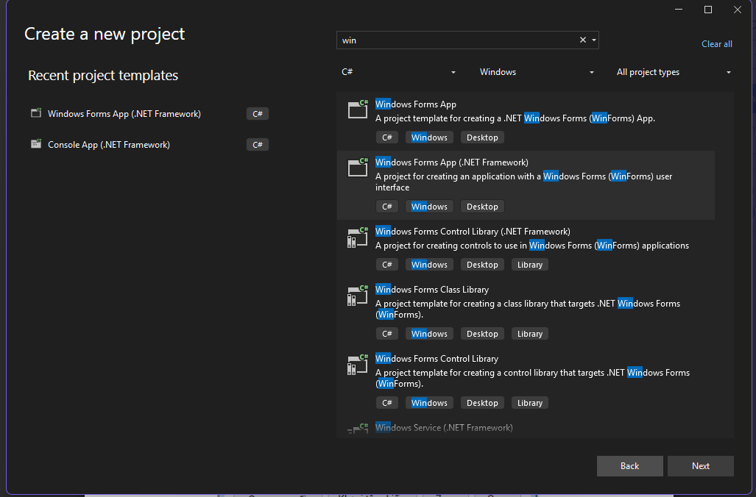

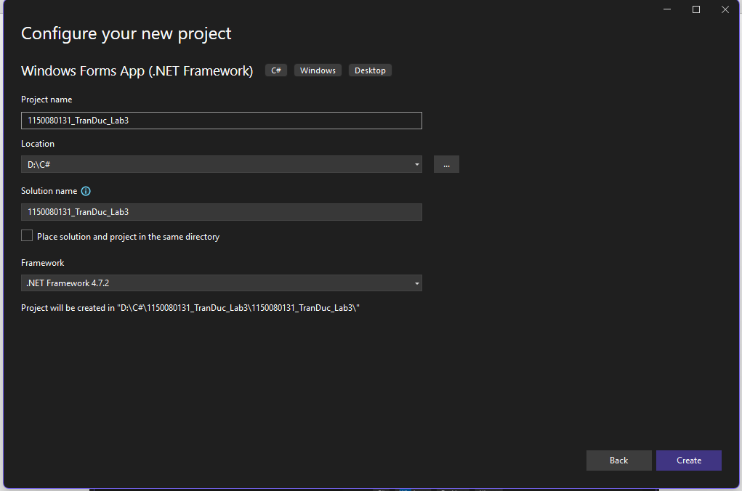

**Thực hành 1: Thiết kế và lập trình ứng dụng Winform theo mô tả sau:**

Tại một quán ăn nhanh, người quản lý sẽ cung cấp cho mỗi nhân vật phục vụ bàn

một máy PDA để order món ăn theo phương thức số hóa. Bởi vậy, khi order xong

các món theo bàn, nhân viên phục vụ bàn sẽ không phải xuống trực tiếp với nhà

bếp mà chuyển thông tin các món khách hàng yêu cầu thông qua hệ thống mạng

không dây. Dưới đây là hình ảnh minh hoạ màn hình làm việc máy PDA đó:

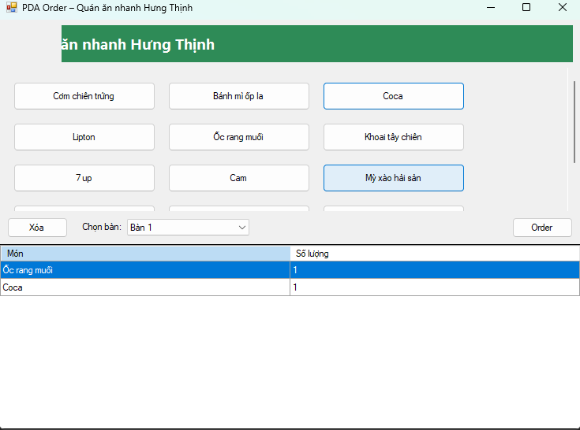

namespace _1150080131_TranDuc_Lab3

{

partial class Form1

{

/// <summary>

/// Required designer variable.

/// </summary>

private System.ComponentModel.IContainer components = null;

private System.Windows.Forms.Panel pnlHeader;

private System.Windows.Forms.PictureBox picLogo;

private System.Windows.Forms.Label lblTitle;

private System.Windows.Forms.FlowLayoutPanel pnlMenu;

private System.Windows.Forms.Panel pnlToolbar;

private System.Windows.Forms.Button btnDelete;

private System.Windows.Forms.Label lblChooseTable;

private System.Windows.Forms.ComboBox cboTable;

private System.Windows.Forms.Button btnOrder;

private System.Windows.Forms.DataGridView dgv;

/// <summary>

/// Clean up any resources being used.

/// </summary>

protected override void Dispose(bool disposing)

{

if (disposing && (components != null))

components.Dispose();

base.Dispose(disposing);

}

#region Windows Form Designer generated code

/// <summary>

/// Required method for Designer support.

/// </summary>

private void InitializeComponent()

{

this.components = new System.ComponentModel.Container();

this.pnlHeader = new System.Windows.Forms.Panel();

this.picLogo = new System.Windows.Forms.PictureBox();

this.lblTitle = new System.Windows.Forms.Label();

this.pnlMenu = new System.Windows.Forms.FlowLayoutPanel();

this.pnlToolbar = new System.Windows.Forms.Panel();

this.btnDelete = new System.Windows.Forms.Button();

this.lblChooseTable = new System.Windows.Forms.Label();

this.cboTable = new System.Windows.Forms.ComboBox();

this.btnOrder = new System.Windows.Forms.Button();

this.dgv = new System.Windows.Forms.DataGridView();

this.pnlHeader.SuspendLayout();

((System.ComponentModel.ISupportInitialize)(this.picLogo)).BeginInit();

this.pnlToolbar.SuspendLayout();

((System.ComponentModel.ISupportInitialize)(this.dgv)).BeginInit();

this.SuspendLayout();

//

// pnlHeader

//

this.pnlHeader.Controls.Add(this.picLogo);

this.pnlHeader.Controls.Add(this.lblTitle);

this.pnlHeader.Dock = System.Windows.Forms.DockStyle.Top;

this.pnlHeader.Location = new System.Drawing.Point(0, 0);

this.pnlHeader.Name = "pnlHeader";

this.pnlHeader.Padding = new System.Windows.Forms.Padding(12, 8, 12, 8);

this.pnlHeader.Size = new System.Drawing.Size(860, 70);

this.pnlHeader.TabIndex = 0;

//

// picLogo

//

this.picLogo.Dock = System.Windows.Forms.DockStyle.Left;

this.picLogo.Location = new System.Drawing.Point(12, 8);

this.picLogo.Name = "picLogo";

this.picLogo.Size = new System.Drawing.Size(80, 54);

this.picLogo.SizeMode = System.Windows.Forms.PictureBoxSizeMode.Zoom;

this.picLogo.TabIndex = 0;

this.picLogo.TabStop = false;

// (tuỳ ý gán Image trong Designer sau)

//

// lblTitle

//

this.lblTitle.BackColor = System.Drawing.Color.SeaGreen;

this.lblTitle.Dock = System.Windows.Forms.DockStyle.Fill;

this.lblTitle.Font = new System.Drawing.Font("Segoe UI", 14.25F, System.Drawing.FontStyle.Bold);

this.lblTitle.ForeColor = System.Drawing.Color.White;

this.lblTitle.Location = new System.Drawing.Point(92, 8);

this.lblTitle.Name = "lblTitle";

this.lblTitle.Padding = new System.Windows.Forms.Padding(12, 8, 12, 8);

this.lblTitle.Size = new System.Drawing.Size(756, 54);

this.lblTitle.TabIndex = 1;

this.lblTitle.Text = "Quán ăn nhanh Hưng Thịnh";

this.lblTitle.TextAlign = System.Drawing.ContentAlignment.MiddleLeft;

//

// pnlMenu

//

this.pnlMenu.AutoScroll = true;

this.pnlMenu.Dock = System.Windows.Forms.DockStyle.Top;

this.pnlMenu.Location = new System.Drawing.Point(0, 70);

this.pnlMenu.Margin = new System.Windows.Forms.Padding(8);

this.pnlMenu.Name = "pnlMenu";

this.pnlMenu.Padding = new System.Windows.Forms.Padding(12);

this.pnlMenu.Size = new System.Drawing.Size(860, 210);

this.pnlMenu.TabIndex = 1;

this.pnlMenu.WrapContents = true;

this.pnlMenu.FlowDirection = System.Windows.Forms.FlowDirection.LeftToRight;

//

// pnlToolbar

//

this.pnlToolbar.Controls.Add(this.btnDelete);

this.pnlToolbar.Controls.Add(this.lblChooseTable);

this.pnlToolbar.Controls.Add(this.cboTable);

this.pnlToolbar.Controls.Add(this.btnOrder);

this.pnlToolbar.Dock = System.Windows.Forms.DockStyle.Top;

this.pnlToolbar.Location = new System.Drawing.Point(0, 280);

this.pnlToolbar.Name = "pnlToolbar";

this.pnlToolbar.Padding = new System.Windows.Forms.Padding(12, 6, 12, 6);

this.pnlToolbar.Size = new System.Drawing.Size(860, 48);

this.pnlToolbar.TabIndex = 2;

//

// btnDelete

//

this.btnDelete.Location = new System.Drawing.Point(12, 9);

this.btnDelete.Name = "btnDelete";

this.btnDelete.Size = new System.Drawing.Size(90, 30);

this.btnDelete.TabIndex = 0;

this.btnDelete.Text = "Xóa";

this.btnDelete.UseVisualStyleBackColor = true;

this.btnDelete.Click += new System.EventHandler(this.btnDelete_Click);

//

// lblChooseTable

//

this.lblChooseTable.AutoSize = true;

this.lblChooseTable.Location = new System.Drawing.Point(120, 15);

this.lblChooseTable.Name = "lblChooseTable";

this.lblChooseTable.Size = new System.Drawing.Size(63, 15);

this.lblChooseTable.TabIndex = 1;

this.lblChooseTable.Text = "Chọn bàn:";

//

// cboTable

//

this.cboTable.DropDownStyle = System.Windows.Forms.ComboBoxStyle.DropDownList;

this.cboTable.FormattingEnabled = true;

this.cboTable.Location = new System.Drawing.Point(189, 11);

this.cboTable.Name = "cboTable";

this.cboTable.Size = new System.Drawing.Size(180, 23);

this.cboTable.TabIndex = 2;

//

// btnOrder

//

this.btnOrder.Anchor = ((System.Windows.Forms.AnchorStyles)((System.Windows.Forms.AnchorStyles.Top | System.Windows.Forms.AnchorStyles.Right)));

this.btnOrder.Location = new System.Drawing.Point(758, 9);

this.btnOrder.Name = "btnOrder";

this.btnOrder.Size = new System.Drawing.Size(90, 30);

this.btnOrder.TabIndex = 3;

this.btnOrder.Text = "Order";

this.btnOrder.UseVisualStyleBackColor = true;

this.btnOrder.Click += new System.EventHandler(this.btnOrder_Click);

//

// dgv

//

this.dgv.AllowUserToAddRows = false;

this.dgv.AllowUserToDeleteRows = false;

this.dgv.AutoSizeColumnsMode = System.Windows.Forms.DataGridViewAutoSizeColumnsMode.Fill;

this.dgv.BackgroundColor = System.Drawing.SystemColors.ControlLightLight;

this.dgv.ColumnHeadersHeightSizeMode = System.Windows.Forms.DataGridViewColumnHeadersHeightSizeMode.AutoSize;

this.dgv.Dock = System.Windows.Forms.DockStyle.Fill;

this.dgv.Location = new System.Drawing.Point(0, 328);

this.dgv.MultiSelect = false;

this.dgv.Name = "dgv";

this.dgv.ReadOnly = true;

this.dgv.RowHeadersVisible = false;

this.dgv.SelectionMode = System.Windows.Forms.DataGridViewSelectionMode.FullRowSelect;

this.dgv.Size = new System.Drawing.Size(860, 272);

this.dgv.TabIndex = 3;

//

// Form1

//

this.AutoScaleDimensions = new System.Drawing.SizeF(7F, 15F);

this.AutoScaleMode = System.Windows.Forms.AutoScaleMode.Font;

this.ClientSize = new System.Drawing.Size(860, 600);

this.Controls.Add(this.dgv);

this.Controls.Add(this.pnlToolbar);

this.Controls.Add(this.pnlMenu);

this.Controls.Add(this.pnlHeader);

this.Name = "Form1";

this.StartPosition = System.Windows.Forms.FormStartPosition.CenterScreen;

this.Text = "PDA Order – Quán ăn nhanh Hưng Thịnh";

this.Load += new System.EventHandler(this.Form1_Load);

this.pnlHeader.ResumeLayout(false);

((System.ComponentModel.ISupportInitialize)(this.picLogo)).EndInit();

this.pnlToolbar.ResumeLayout(false);

this.pnlToolbar.PerformLayout();

((System.ComponentModel.ISupportInitialize)(this.dgv)).EndInit();

this.ResumeLayout(false);

}

#endregion

}

}

using System;

using System.Data;

using System.Linq;

using System.Text;

using System.IO;

using System.Windows.Forms;

namespace _1150080131_TranDuc_Lab3

{

public partial class Form1 : Form

{

private DataTable orderTable;

private readonly string[] MENU = {

"Cơm chiên trứng","Bánh mì ốp la","Coca","Lipton",

"Ốc rang muối","Khoai tây chiên","7 up","Cam",

"Mỳ xào hải sản","Cá viên chiên","Pepsi","Cafe",

"Buger bò nướng","Đùi gà rán","Bún bò Huế"

};

public Form1() { InitializeComponent(); }

private void Form1_Load(object sender, EventArgs e)

{

// Bàn

cboTable.Items.AddRange(Enumerable.Range(1, 20).Select(i => $"Bàn {i}").ToArray());

cboTable.SelectedIndex = 0;

// Grid

orderTable = new DataTable();

orderTable.Columns.Add("Món", typeof(string));

orderTable.Columns.Add("Số lượng", typeof(int));

dgv.DataSource = orderTable;

// Sinh nút món

foreach (var name in MENU)

{

var b = new Button { Text = name, Width = 180, Height = 36, Margin = new Padding(8) };

b.Click += (s, _) => AddOrIncrease(name);

pnlMenu.Controls.Add(b);

}

}

private void AddOrIncrease(string name)

{

foreach (DataRow r in orderTable.Rows)

if ((string)r["Món"] == name) { r["Số lượng"] = (int)r["Số lượng"] + 1; return; }

orderTable.Rows.Add(name, 1);

}

private void btnDelete_Click(object sender, EventArgs e)

{

if (dgv.CurrentRow != null)

dgv.Rows.RemoveAt(dgv.CurrentRow.Index);

}

private void btnOrder_Click(object sender, EventArgs e)

{

if (orderTable.Rows.Count == 0)

{

MessageBox.Show("Chưa có món nào!"); return;

}

var dir = Path.Combine(AppDomain.CurrentDomain.BaseDirectory, "Orders");

Directory.CreateDirectory(dir);

var fname = $"{cboTable.SelectedItem}_{DateTime.Now:yyyyMMdd_HHmmss}.txt";

var path = Path.Combine(dir, fname);

var sb = new StringBuilder();

sb.AppendLine($"BÀN: {cboTable.SelectedItem}");

sb.AppendLine($"Thời gian: {DateTime.Now:dd/MM/yyyy HH:mm:ss}");

sb.AppendLine(new string('-', 40));

foreach (DataRow r in orderTable.Rows)

sb.AppendLine($"{r["Món"]} x {r["Số lượng"]}");

File.WriteAllText(path, sb.ToString(), Encoding.UTF8);

MessageBox.Show($"Đã ghi file:\n{path}");

orderTable.Clear();

}

}

}

**Thực hành 2: Tạo mới 1 project có tên là “ThucHanh2” với form chính được**

**minh họa như sau:**

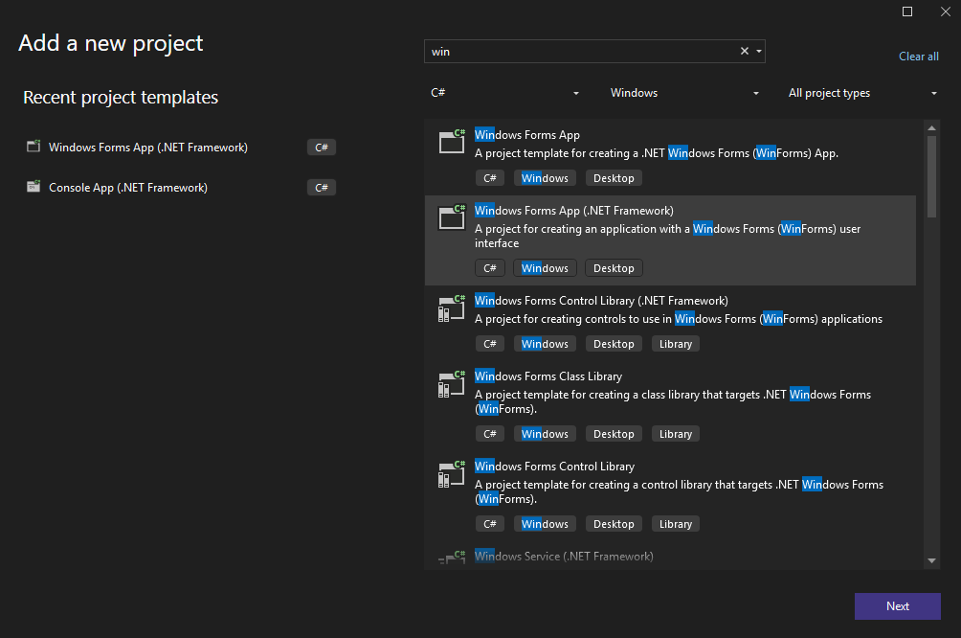

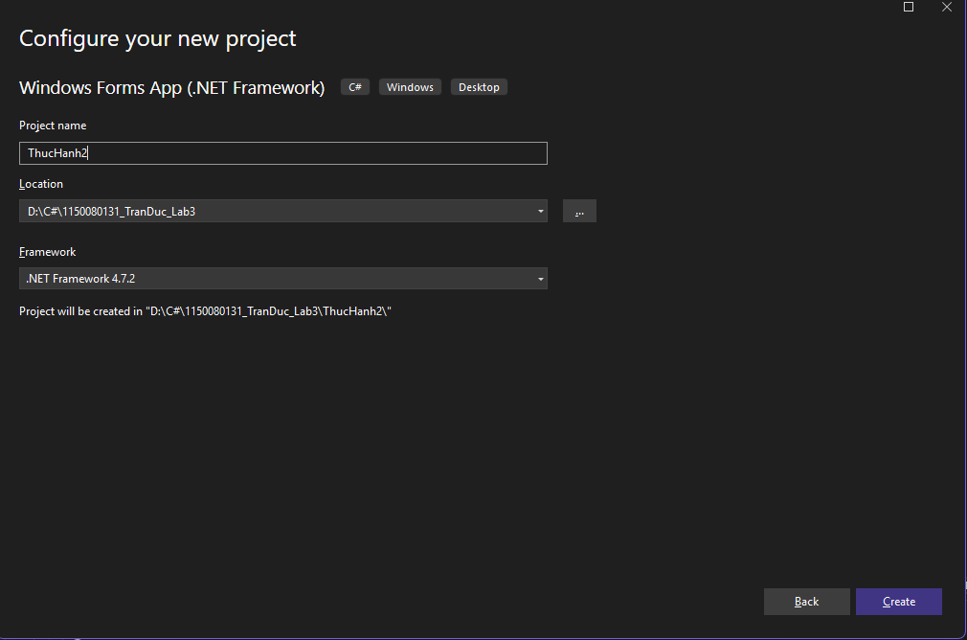

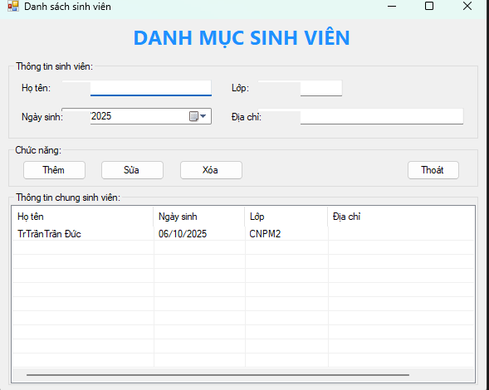

namespace ThucHanh2

{

partial class Form1

{

private System.ComponentModel.IContainer components = null;

private System.Windows.Forms.Label lblTitle;

private System.Windows.Forms.GroupBox grpInfo;

private System.Windows.Forms.Label lblHoTen;

private System.Windows.Forms.TextBox txtHoTen;

private System.Windows.Forms.Label lblNgaySinh;

private System.Windows.Forms.DateTimePicker dtpNgaySinh;

private System.Windows.Forms.Label lblLop;

private System.Windows.Forms.TextBox txtLop;

private System.Windows.Forms.Label lblDiaChi;

private System.Windows.Forms.TextBox txtDiaChi;

private System.Windows.Forms.GroupBox grpActions;

private System.Windows.Forms.Button btnThem;

private System.Windows.Forms.Button btnSua;

private System.Windows.Forms.Button btnXoa;

private System.Windows.Forms.Button btnThoat;

private System.Windows.Forms.GroupBox grpList;

private System.Windows.Forms.ListView lvSinhVien;

private System.Windows.Forms.ColumnHeader colHoTen;

private System.Windows.Forms.ColumnHeader colNgaySinh;

private System.Windows.Forms.ColumnHeader colLop;

private System.Windows.Forms.ColumnHeader colDiaChi;

protected override void Dispose(bool disposing)

{

if (disposing && (components != null)) components.Dispose();

base.Dispose(disposing);

}

#region Windows Form Designer generated code

private void InitializeComponent()

{

this.lblTitle = new System.Windows.Forms.Label();

this.grpInfo = new System.Windows.Forms.GroupBox();

this.lblHoTen = new System.Windows.Forms.Label();

this.txtHoTen = new System.Windows.Forms.TextBox();

this.lblNgaySinh = new System.Windows.Forms.Label();

this.dtpNgaySinh = new System.Windows.Forms.DateTimePicker();

this.lblLop = new System.Windows.Forms.Label();

this.txtLop = new System.Windows.Forms.TextBox();

this.lblDiaChi = new System.Windows.Forms.Label();

this.txtDiaChi = new System.Windows.Forms.TextBox();

this.grpActions = new System.Windows.Forms.GroupBox();

this.btnThem = new System.Windows.Forms.Button();

this.btnSua = new System.Windows.Forms.Button();

this.btnXoa = new System.Windows.Forms.Button();

this.btnThoat = new System.Windows.Forms.Button();

this.grpList = new System.Windows.Forms.GroupBox();

this.lvSinhVien = new System.Windows.Forms.ListView();

this.colHoTen = new System.Windows.Forms.ColumnHeader();

this.colNgaySinh = new System.Windows.Forms.ColumnHeader();

this.colLop = new System.Windows.Forms.ColumnHeader();

this.colDiaChi = new System.Windows.Forms.ColumnHeader();

this.grpInfo.SuspendLayout();

this.grpActions.SuspendLayout();

this.grpList.SuspendLayout();

this.SuspendLayout();

// lblTitle

this.lblTitle.Dock = System.Windows.Forms.DockStyle.Top;

this.lblTitle.Font = new System.Drawing.Font("Segoe UI", 18F, System.Drawing.FontStyle.Bold);

this.lblTitle.ForeColor = System.Drawing.Color.DodgerBlue;

this.lblTitle.Text = "DANH MỤC SINH VIÊN";

this.lblTitle.TextAlign = System.Drawing.ContentAlignment.MiddleCenter;

this.lblTitle.Height = 50;

// grpInfo

this.grpInfo.Text = "Thông tin sinh viên:";

this.grpInfo.Location = new System.Drawing.Point(12, 58);

this.grpInfo.Size = new System.Drawing.Size(660, 110);

// Họ tên

this.lblHoTen.Text = "Họ tên:";

this.lblHoTen.Location = new System.Drawing.Point(15, 30);

this.txtHoTen.Location = new System.Drawing.Point(75, 27);

this.txtHoTen.Size = new System.Drawing.Size(210, 23);

// Lớp

this.lblLop.Text = "Lớp:";

this.lblLop.Location = new System.Drawing.Point(310, 30);

this.txtLop.Location = new System.Drawing.Point(350, 27);

this.txtLop.Size = new System.Drawing.Size(120, 23);

// Ngày sinh

this.lblNgaySinh.Text = "Ngày sinh:";

this.lblNgaySinh.Location = new System.Drawing.Point(15, 70);

this.dtpNgaySinh.Location = new System.Drawing.Point(75, 66);

this.dtpNgaySinh.Size = new System.Drawing.Size(210, 23);

this.dtpNgaySinh.Format = System.Windows.Forms.DateTimePickerFormat.Custom;

this.dtpNgaySinh.CustomFormat = "dd/MM/yyyy";

// Địa chỉ

this.lblDiaChi.Text = "Địa chỉ:";

this.lblDiaChi.Location = new System.Drawing.Point(310, 70);

this.txtDiaChi.Location = new System.Drawing.Point(350, 66);

this.txtDiaChi.Size = new System.Drawing.Size(290, 23);

// add to grpInfo

this.grpInfo.Controls.AddRange(new System.Windows.Forms.Control[] {

this.lblHoTen, this.txtHoTen,

this.lblLop, this.txtLop,

this.lblNgaySinh, this.dtpNgaySinh,

this.lblDiaChi, this.txtDiaChi

});

// grpActions

this.grpActions.Text = "Chức năng:";

this.grpActions.Location = new System.Drawing.Point(12, 174);

this.grpActions.Size = new System.Drawing.Size(660, 60);

// buttons

this.btnThem.Text = "Thêm";

this.btnThem.Location = new System.Drawing.Point(20, 22);

this.btnThem.Size = new System.Drawing.Size(90, 28);

this.btnThem.Click += new System.EventHandler(this.btnThem_Click);

this.btnSua.Text = "Sửa";

this.btnSua.Location = new System.Drawing.Point(130, 22);

this.btnSua.Size = new System.Drawing.Size(90, 28);

this.btnSua.Click += new System.EventHandler(this.btnSua_Click);

this.btnXoa.Text = "Xóa";

this.btnXoa.Location = new System.Drawing.Point(240, 22);

this.btnXoa.Size = new System.Drawing.Size(90, 28);

this.btnXoa.Click += new System.EventHandler(this.btnXoa_Click);

this.btnThoat.Text = "Thoát";

this.btnThoat.Location = new System.Drawing.Point(560, 22);

this.btnThoat.Size = new System.Drawing.Size(75, 28);

this.btnThoat.Click += new System.EventHandler(this.btnThoat_Click);

this.grpActions.Controls.AddRange(new System.Windows.Forms.Control[] {

this.btnThem, this.btnSua, this.btnXoa, this.btnThoat

});

// grpList

this.grpList.Text = "Thông tin chung sinh viên:";

this.grpList.Location = new System.Drawing.Point(12, 240);

this.grpList.Size = new System.Drawing.Size(660, 270);

// ListView

this.lvSinhVien.Dock = System.Windows.Forms.DockStyle.Fill;

this.lvSinhVien.FullRowSelect = true;

this.lvSinhVien.GridLines = true;

this.lvSinhVien.HideSelection = false;

this.lvSinhVien.MultiSelect = false;

this.lvSinhVien.View = System.Windows.Forms.View.Details;

this.lvSinhVien.Columns.AddRange(new System.Windows.Forms.ColumnHeader[] {

this.colHoTen, this.colNgaySinh, this.colLop, this.colDiaChi

});

this.lvSinhVien.SelectedIndexChanged += new System.EventHandler(this.lvSinhVien_SelectedIndexChanged);

this.colHoTen.Text = "Họ tên";

this.colHoTen.Width = 170;

this.colNgaySinh.Text = "Ngày sinh";

this.colNgaySinh.Width = 110;

this.colLop.Text = "Lớp";

this.colLop.Width = 100;

this.colDiaChi.Text = "Địa chỉ";

this.colDiaChi.Width = 250;

this.grpList.Controls.Add(this.lvSinhVien);

// Form1

this.AutoScaleDimensions = new System.Drawing.SizeF(7F, 15F);

this.AutoScaleMode = System.Windows.Forms.AutoScaleMode.Font;

this.ClientSize = new System.Drawing.Size(684, 521);

this.Controls.Add(this.grpList);

this.Controls.Add(this.grpActions);

this.Controls.Add(this.grpInfo);

this.Controls.Add(this.lblTitle);

this.Name = "Form1";

this.StartPosition = System.Windows.Forms.FormStartPosition.CenterScreen;

this.Text = "Danh sách sinh viên";

this.grpInfo.ResumeLayout(false);

this.grpInfo.PerformLayout();

this.grpActions.ResumeLayout(false);

this.grpList.ResumeLayout(false);

this.ResumeLayout(false);

}

#endregion

}

}

using System;

using System.Windows.Forms;

namespace ThucHanh2

{

public partial class Form1 : Form

{

public Form1() { InitializeComponent(); }

// Kiểm tra dữ liệu tối thiểu

private bool ValidateInput()

{

if (string.IsNullOrWhiteSpace(txtHoTen.Text))

{

MessageBox.Show("Họ tên không được rỗng.", "Lỗi nhập liệu",

MessageBoxButtons.OK, MessageBoxIcon.Warning);

txtHoTen.Focus();

return false;

}

return true;

}

private void btnThem_Click(object sender, EventArgs e)

{

if (!ValidateInput()) return;

var item = new ListViewItem(txtHoTen.Text.Trim());

item.SubItems.Add(dtpNgaySinh.Value.ToString("dd/MM/yyyy"));

item.SubItems.Add(txtLop.Text.Trim());

item.SubItems.Add(txtDiaChi.Text.Trim());

lvSinhVien.Items.Add(item);

ClearInputs();

}

private void btnSua_Click(object sender, EventArgs e)

{

if (lvSinhVien.SelectedItems.Count == 0)

{

MessageBox.Show("Hãy chọn 1 dòng để sửa.", "Thông báo",

MessageBoxButtons.OK, MessageBoxIcon.Information);

return;

}

if (!ValidateInput()) return;

var it = lvSinhVien.SelectedItems[0];

it.Text = txtHoTen.Text.Trim();

it.SubItems[1].Text = dtpNgaySinh.Value.ToString("dd/MM/yyyy");

it.SubItems[2].Text = txtLop.Text.Trim();

it.SubItems[3].Text = txtDiaChi.Text.Trim();

}

private void btnXoa_Click(object sender, EventArgs e)

{

if (lvSinhVien.SelectedItems.Count == 0)

{

MessageBox.Show("Hãy chọn 1 dòng để xóa.", "Thông báo",

MessageBoxButtons.OK, MessageBoxIcon.Information);

return;

}

if (MessageBox.Show("Bạn có chắc muốn xóa dòng đã chọn?",

"Xác nhận", MessageBoxButtons.YesNo, MessageBoxIcon.Question) == DialogResult.Yes)

{

lvSinhVien.Items.Remove(lvSinhVien.SelectedItems[0]);

ClearInputs();

}

}

private void btnThoat_Click(object sender, EventArgs e)

{

Close();

}

// Khi chọn 1 dòng -> đổ dữ liệu lên form

private void lvSinhVien_SelectedIndexChanged(object sender, EventArgs e)

{

if (lvSinhVien.SelectedItems.Count == 0) return;

var it = lvSinhVien.SelectedItems[0];

txtHoTen.Text = it.Text;

if (DateTime.TryParse(it.SubItems[1].Text, out var d))

dtpNgaySinh.Value = d;

else

dtpNgaySinh.Value = DateTime.Today;

txtLop.Text = it.SubItems[2].Text;

txtDiaChi.Text = it.SubItems[3].Text;

}

private void ClearInputs()

{

txtHoTen.Clear();

txtLop.Clear();

txtDiaChi.Clear();

dtpNgaySinh.Value = DateTime.Today;

txtHoTen.Focus();

}

}

}